DB725742 Ku Su Wa
CISC3029 LAB 9 Edge Detection

MATLAB function edge takes the intensity or a binary image I as its input, and returns a binary image BW of the same size as I, with 1's where the function finds edges in I and 0's elsewhere.

EDGE supports six different edge-finding methods. They are Sobel method, Prewitt method, Roberts method, Laplacian of Gaussian method, zero-cross method, and Canny method.

Exercise: Analyze each edge detector by choosing different parameters.

Request: i). Choose at least three images, including image without noise, image with noise, and image with clustered background.
ii). Apply each method to the selected image with different parameters, analyze the result images.
iii). Canny edge detector is recognized as an optimal edge detector. Do you have any evidence based on your own experiments?

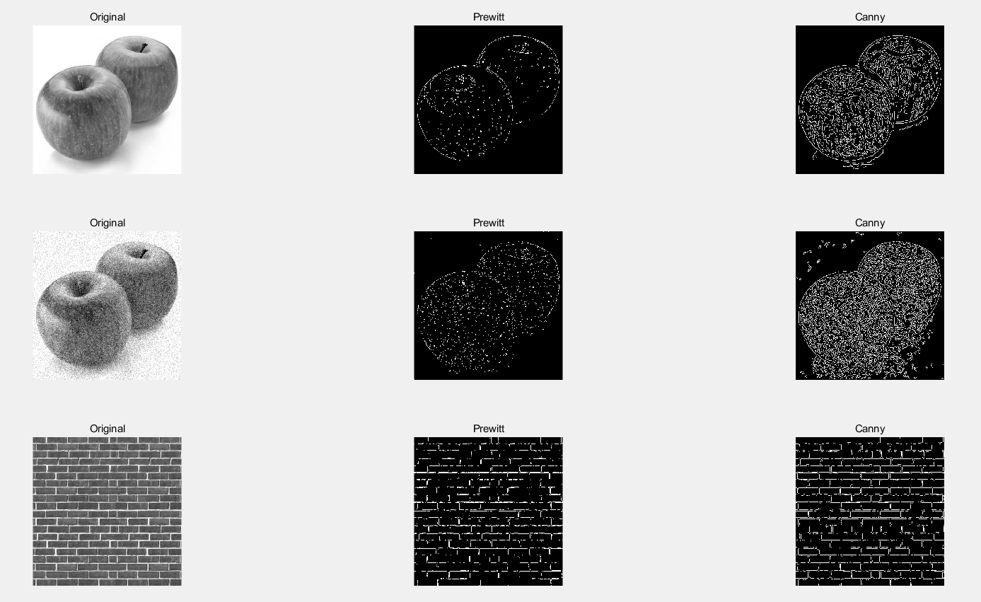
Request: i)
Request: ii)
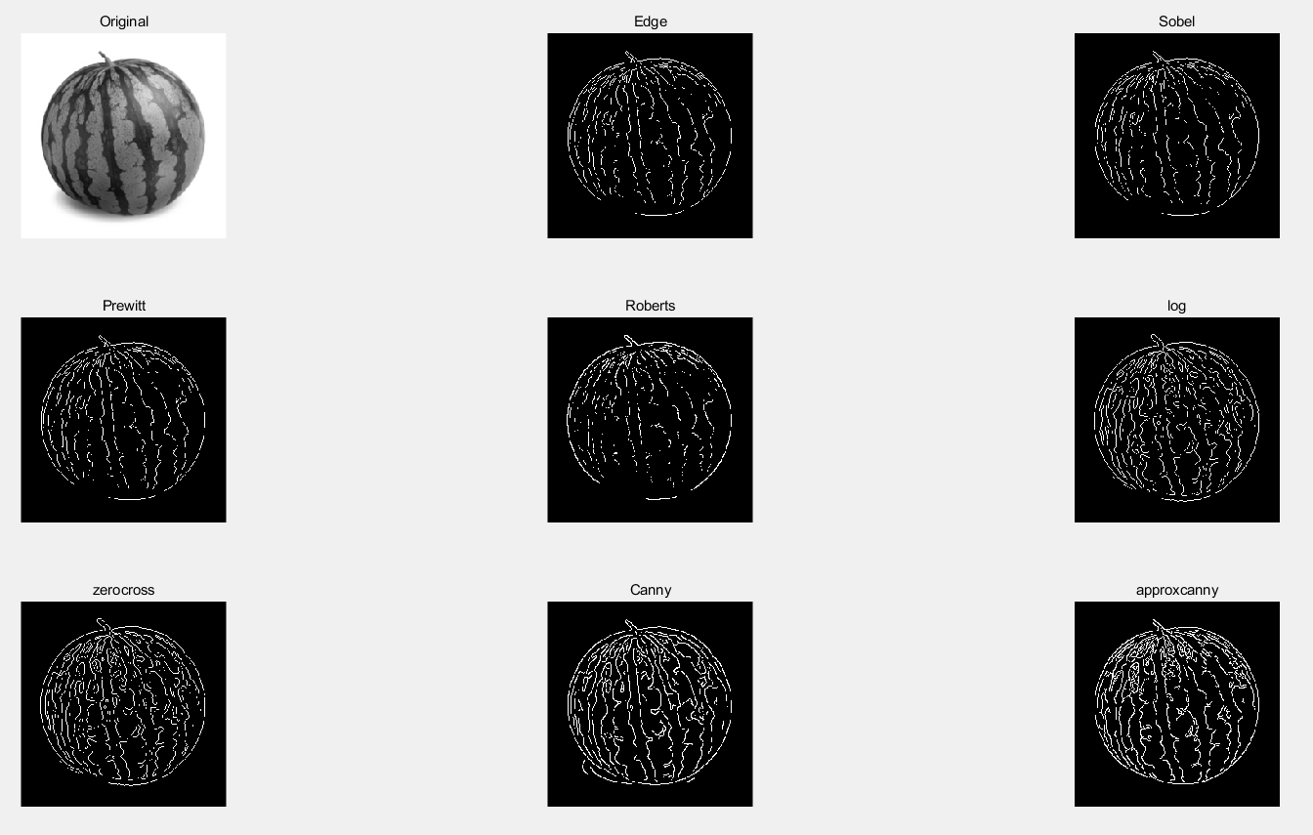
Method | Description
Sobel | Finds edges at those points where the gradient of the image I is maximum, using the Sobel approximation to the derivative.
Prewitt | Finds edges at those points where the gradient of I is maximum, using the Prewitt approximation to the derivative.
Roberts | Finds edges at those points where the gradient of I is maximum, using the Roberts approximation to the derivative.
log | Finds edges by looking for zero-crossings after filtering I with a Laplacian of Gaussian (LoG) filter.
zerocross | Finds edges by looking for zero-crossings after filtering I with a filter that you specify
Canny | Finds edges by looking for local maxima of the gradient of I. The edge function calculates the gradient using the derivative of a Gaussian filter. This method uses two thresholds to detect strong and weak edges, including weak edges in the output if they are connected to strong edges. By using two thresholds, the Canny method is less likely than the other methods to be fooled by noise, and more likely to detect true weak edges.
approxcanny | Finds edges using an approximate version of the Canny edge detection algorithm that provides faster execution time at the expense of less precise detection. Floating point images are expected to be normalized in the range [0 1].

Request: iii)
Usually, for using Canny Edge Detection, we have to input an image and other parameters (i.e threshold). But, with this function, we just have to input the image, no need to input the threshold value. Canny edge detection is accomplished using the edge function. Matlab will get "automatic/adaptive" thresholds if you don't specify thresholds as an argument. So, we can get the edge fastly.

